Build a VPC with Public and Private Subnets

1. **Log into AWS Management Console.**
2. **Created a VPC without using the VPC Wizard.**
3. **Created an Internet Gateway.**
4. **Created private and public subnets for the VPC.**
5. **Created and Configure Route tables.**

**Created a VPC without using VPC Wizard. Created our own public and private subnets. Along with that, we will be configuring Route tables**

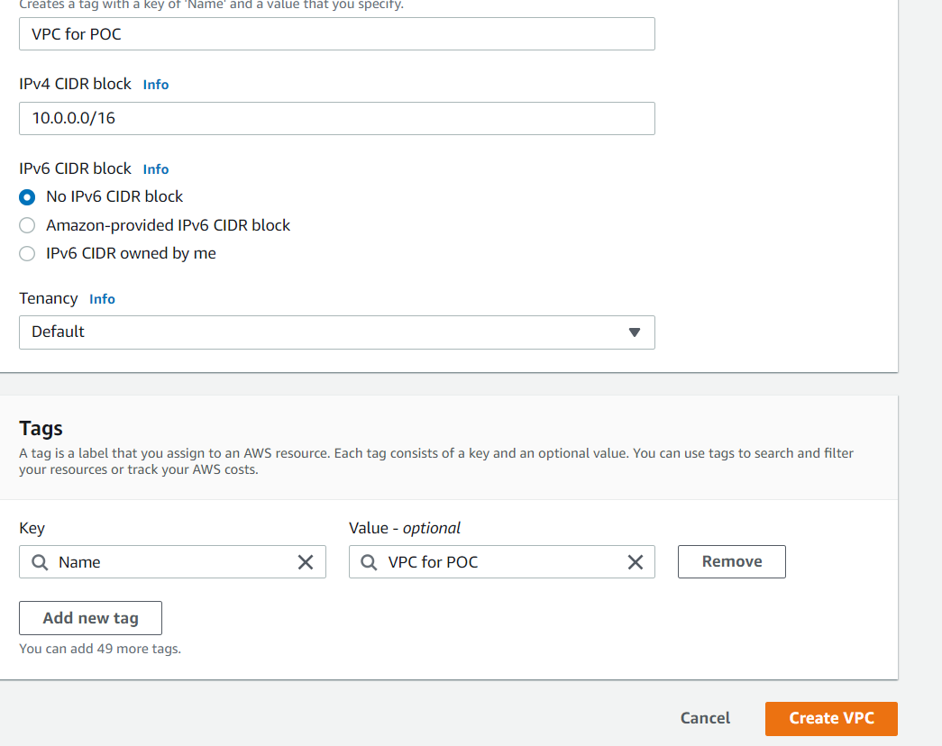

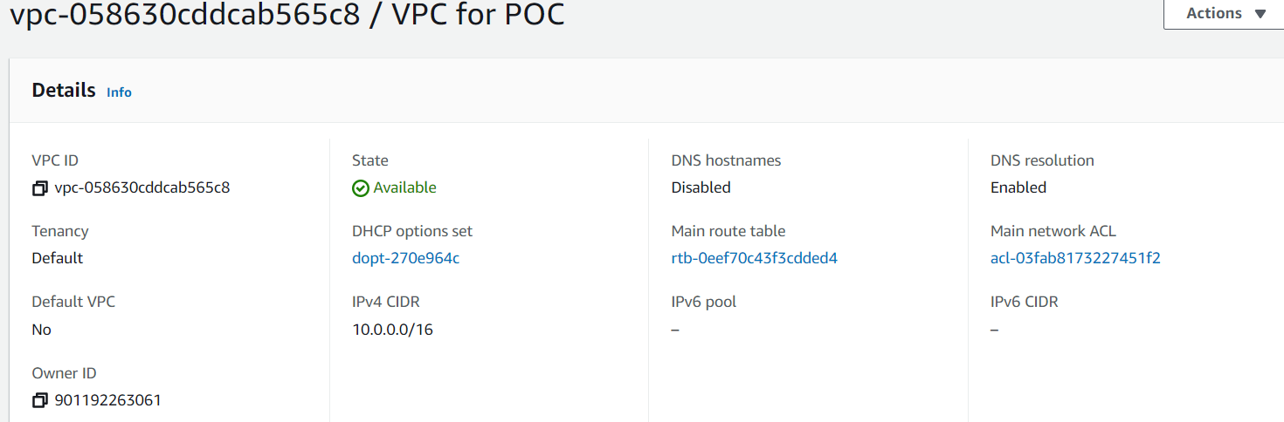

Created one Public Subnet and one private subnet



Create and configure Internet Gateway

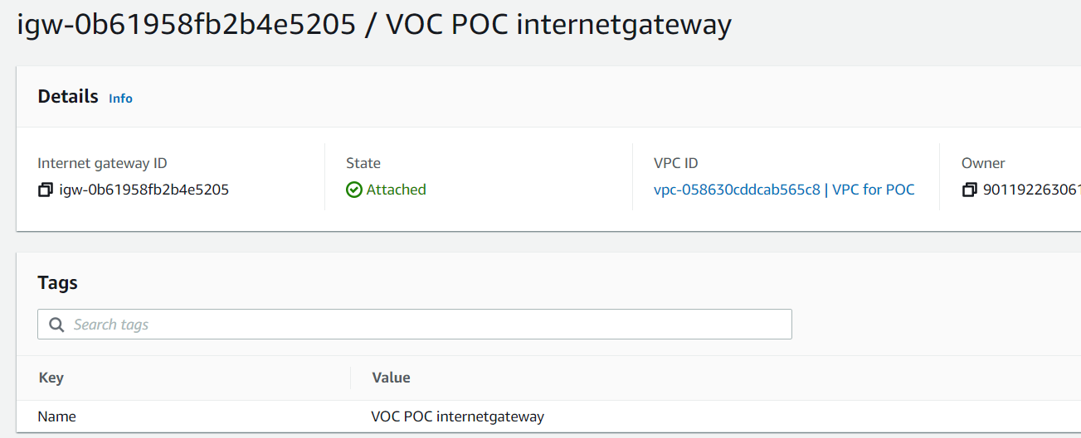

Create a public and private route tables

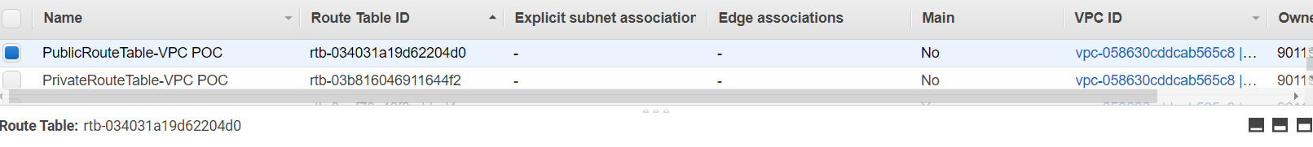

Now associated the subnets to the route tables and Add a route to allow Internet traffic to the VPC.

Validation Test

**The instances launched inside the public subnet will be able to access the internet and instances launched inside the private subnet will not have access to the internet**.

